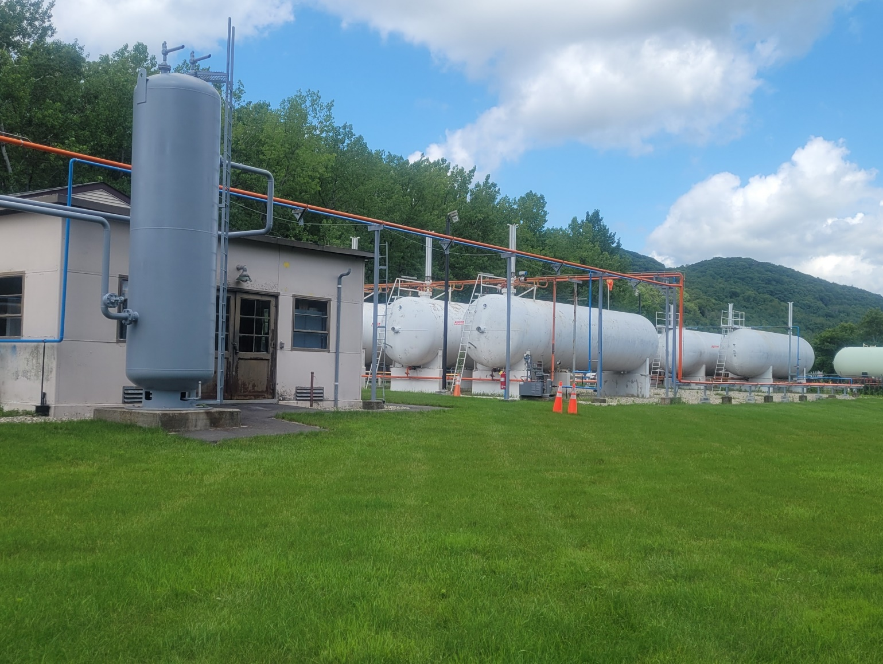

**Initial Publication 02/01/2022**

Change Summary:

n/a

Table of Contents

Table of Contents 1-1

Section 1. Introduction 1-1

Section 2. Code References, Design Baseline and Criteria 2-1

2.1 Code References 2-1

2.2 Additional Codes 2-1

2.3 Applicable Massachusetts State Codes 2-1

2.4 LP Plant Description 2-1

2.5 LP Tank Liquid Level Chart 2-1

2.6 Facility Description 2-2

2.7 SENDOUT 2-2

2.8 LP Storage Tanks 2-3

2.9 Piping External to the Tanks 2-4

2.10 Tank Specifications 2-4

2.11 LP Transport Unload Pump Skid 2-4

2.11.1 Greenfield LP Transfer Station 2-6

2.11.2 North Adams LP Transfer Station 2-8

2.11.3 Pittsfield LP Transfer Station 2-9

2.11.4 Fuel Transfer Pump Data 2-10

Section 3. Vaporization 3-1

3.1 Overview 3-1

3.1.1 Greenfield LP Plant Vaporization 3-2

3.1.2 N. Adams and Pittsfield LP Plant Vaporization 3-3

3.2 Plant Emergency Shutdowns 3-4

3.2.1 ESD Emergency Shutdown Activation 3-4

3.2.2 Relief Valves 3-4

3.2.3 Gas Detection 3-4

3.2.4 Fire Detection 3-5

3.2.5 Alarm Annunciators 3-5

3.2.6 Fire Protection 3-5

3.3 HMI Screens 3-5

3.3.1 Greenfield description and/or technical specifications/Plant Flow Diagrams 3-5

3.3.2 N. Adams and Pittsfield Manual PLC Controls with Local Color Touch Screen 3-5

Section 4. Gas Control Communications 4-1

4.1 System Pressure Flow 4-1

Section 5. Job Classifications 5-1

5.1 Overview 5-1

5.2 Relevant sections of job descriptions related to LPG operations 5-1

5.2.1 Director, LNG/LPG Plants 5-1

5.2.2 Manager, LPG Plants 5-1

5.2.3 Supervisor, LPG Plant 5-1

5.2.4 Senior or Technical Support Specialist 5-1

5.2.5 LPG Technician 5-2

Section 6. Training Components/Checklist 6-1

6.1 Overview 6-1

6.2 Duties 6-1

Section 7. Re-evaluation 7-1

7.1 Overview 7-1

7.2 Review of Contractor Training Requirements 7-1

Section 8. New LP Plant Personnel Checklist 8-1

8.1 Procedure 8-1

Section 9. Appendix 9-1

9.1 List of Tables 9-1

9.2 List of Figures 9-1

# Introduction

“LP Gas” or “Liquefied Petroleum Gas” (LPG) is a term that defines the following hydrocarbons or any fuel product containing a mixture of the following hydrocarbons: propane, butane, and iso-butane.

LPG is primarily produced during the production of LP gas and crude oil from active wells, and is sometimes produced during certain refining processes in oil refineries.

LPG has definite properties that should be fully understood by anyone who participates in the handling, transportation, or storage of this fuel. Thorough knowledge and understanding of the characteristics of LPG is crucial to the safe utilization and handling of LPG.

LPG contains approximately 92,000 BTU/Gal. (46 MJ/Kg. of liquid), and about 2,500 BTU/CuFt. (94 MJ/m3 of vapor). These figures are based on domestic (U.S.) LPG, which is typically 95% propane, 5% butane, and is commonly known as HD-5. In other countries, LPG may contain more butane, sometimes amounting to 70% or more of the total volumetric ratio.

LPG gas is heavier than air. LPG vapor has a specific gravity value of approximately 1.53, which indicates that LPG gas settles in low-lying areas such as holes or cellars. In the event of a release, quantities of LPG tend to pool in recesses where it may ignite before dissipation into the atmosphere can occur.

LPG is converted to the liquid phase by reducing the temperature, applying pressure, or both. Once liquefied, LPG is stored in pressurized cylinders or tanks.

Different grades of LPG may also contain propylenes and/or butylenes. Under normal temperatures and moderate pressures, LPG can be transported and handled easily as a liquid. However, when released at atmospheric pressures and relatively low temperatures, it readily vaporizes and can be used as a gas.

Propane, a primary constituent of LPG, exists as a liquid at atmospheric pressure and temperatures below -44°F (-42°C). At atmospheric pressure and temperatures above -44°F (-42°C), propane will exist as a vapor. Thus, -44°F (-42°C) is known as the saturation temperature of propane at atmospheric pressure.

Propane is converted to vapor (vaporization) by the application of heat energy via special vaporizing equipment. Consequently, at the saturation temperature given a certain pressure, propane will readily vaporize when released. LPG will behave in the same manner but at varying temperatures depending on the ratio of hydrocarbons in the mixture.

An LP Plant is a fully functional facility capable of vaporizing. LPG tanker truck unloading and loading are also characteristics of the facility.

The gas is also colorless and odorless. An odorizing agent called Mercaptan is usually added to provide a mechanism by which leaks can be detected in the absence of special leak detection equipment.

The training of all LP Plant personnel in Operations, Maintenance, Security, Safety, Fire Protection and all other LP Plant activities will be continuous to keep personnel current on the knowledge and skills they gain through experience and initial plant training.

Training and a review of all LP Plant Procedures including but not limited to operations, maintenance, security, emergency, and firefighting will be conducted at intervals not to exceed two years or at reduced intervals where required.

Personnel who have not demonstrated their capability to perform their assigned duties can only operate or maintain equipment when accompanied and directed by an individual qualified to perform these duties at the LP Plant.

# Code References and Plant Descriptions

## Code References

The Greenfield, North Adams, and Pittsfield LP Plants were constructed, operated, and maintained according to the requirements of National Fire Protection Association 59 Utility LP-Gas Plant Code (2004) (NAPA 59).

## Additional Codes

Applicable provisions of 49 CFR Parts 40, 192, and 199.

## Applicable Massachusetts State Codes

Applicable provisions of 220 CMR 101.00: Massachusetts Natural Gas Pipeline Safety Code.

## LP Plant Description

The LP facilities consist of 30,000 gallon or 30,000- and 60,000-gallon LP storage tanks, with truck unloading facilities, vaporizer, control building, control system, and associated piping and attachments. The sites have been designed with the inclusion of LP storage with flowrates, pressures, and temperatures as listed in Table 1.

|  |  |  |  |
| --- | --- | --- | --- |
| Specification | Greenfield | N. Adams | Pittsfield |
| Maximum LP Storage (gallons) | 60,000 x2, 30,000 x2 tanks | 180,000 gallons (6x30,000 Gal. tanks) | 360,000 gallons (6x30,000 Gal. tanks, 3x60,000 Gal. tanks |
| Maximum Sendout Flowrate |  |  |  |
| Minimum Sendout Flowrate |  |  |  |
| Maximum Sendout Pressure |  |  |  |
| Minimum Sendout Pressure |  |  |  |
| Design Sendout Temperature |  |  |  |

Table - LP Plant Descriptions

## LP Tank Liquid Level Chart

| Specification | Greenfield | N. Adams | Pittsfield |
| --- | --- | --- | --- |
| Details on the LP Tanks | Standby Systems, Minneapolis, MN | Superior Energy Systems, Cleveland, OH | Superior Energy Systems, Cleveland, OH |
| Contents/PSIG | Liquid Petroleum Gas (Propane) @ xxx PSIG | Liquid Petroleum Gas (Propane) @ xxx PSIG | Liquid Petroleum Gas (Propane) @ xxx PSIG |
| Liquid Density (Lb./CuFt.) |  |  |  |
| Vapor Density (Lb./CuFt.) |  |  |  |
| Tank Levels |  |  |  |

Table - LP Tank Liquid Levels

## Facility Description

The fundamental features of the facilities are the shop fabricated, LPG storage tanks. The tanks are made of carbon steel (or possibly 9% nickel steel?). The tanks can operate at a pressure of 210 PSIG, which is a sufficient pressure for sendout into the 200 PSIG distribution system without the use of an LPG sendout pump. The tanks are equipped with liquid level indication, vapor space pressure indication, and the appropriate liquid and vapor connections for transfer, pressure build and boiloff.

Each tank is equipped with a boil-off system, which is designed with a backpressure regulator set for the desired tank pressure that vents the design boiloff through a preheating system and into the distribution system. Emergency shutdown values located on each nozzle of each tank are able to be operated either remotely or locally with local and remote indication of valve position. These valves isolate the tanks from the downstream piping and equipment. (Safety features technical specifications).

## SENDOUT

The LPG Plants are equipped with vaporizer and process controls.

A truck unloading area is located remotely from the tanks and is provided with vapor and liquid connections.

The vaporizer, pressure build, and boiloff preheat system is located adjacent to the tanks.

A vertical shell and tube system is located on a skid connected to the liquid out nozzles of the tanks. The vaporizer output is controlled based the position an LPG flow control valve located on the inlet to the vaporizer. The LPG flow control valve is remotely operated in manual position control. Automatic pressure and temperature shutdowns exist as safety overrides. The gas sendout line runs underground to tie into the distribution system.

A stainless-steel control valve is located at discharge the vaporizer prior to transition to carbon steel piping. This is the code required temperature shutdown valve for the facility. The outlet of the vaporizer is all stainless steel, to and including the temperature shutdown valve. This arrangement effectively protects the downstream carbon steel piping systems from gas temperature above or below their design rating which is only expected to occur during an upset condition.

A check valve and a manual block valve in the gas sendout piping prevents backflow and allows for total isolation of the vaporizer and storage tanks from the distribution system.

Heat for vaporization is supplied by water/glycol pumped from the heater room of the control building. The prefabricated pump skid has a stop-start panel as well as valves, strainer/air separator, suction diffusers and expansion tank built in.

A downstream odorant system, located at the discharge the system, injects the required amounts per 220 CMR 101.06(20).

Fuel gas for the water/glycol heater is taken from the sendout.

A single control building is located on each site. It is located in an electrically non-hazardous area. The foam areas contain the municipal water supply tie-in domestic and firewater, and the bladder tank, proportioner and pump for the high expansion foam system. The control rooms contain the power distribution panels, standby generator transfer, electric motor controls, the control RTU and SCADA interface. The heater areas contain the water/glycol heaters, the water/glycol pump skid, the instrument compressor and the sendout gas BTU analyzer. The odorant areas contain the odorant injection pump, panel, and odorant storage vessel.

User interface controls and monitoring of each facility occurs at the Human-Machine Interface (HMI) at the control room.

All electrical equipment is installed in accordance with the area classification in which it operates.

A fire and gas detection systems, complete with the requisite audible and visual alarms, are installed at the facilities to monitor each tank, the vaporizer area, the truck unloading station, and each room of the control building.

Microphone/loudspeaker and intrinsically-safe handheld radios for communications within and outside of each facility are provided. Also telephones and intercom speakers are located at the truck unloading stations, vaporizer skids, and in each room of the control buildings.

A perimeter security system is provided to monitor unauthorized access into the LPG tanks and process areas. Door switches are provided on each door of the control buildings to monitor unauthorized access into any building. Key access is required through the facility main gate and the main control room door.

## LP Storage Tanks

The storage tanks were designed, built, and workmanship conform to ASME Rules Section VIII, Div. 1. The chemical and physical properties of all parts meet the requirements of materials specifications of the ASME BOILER AND PRESSURE VESSEL CODE. The vessel shell welds were 100% radiographed and head welds were spot radiographed.

They were designed in accordance with the requirements of the Compressed Gas Association ("CGA") Standard 341, Paragraphs 3.6.2.1, 3.6.2.2, 3.6.2.3, 3.6.2.4, 3.6.2.5,·and 3.6.4, except that the shock load factors of Paragraph 3.4 were not applicable.

Piping connecting to the vessels conforms to ANSI B31.3. It is weldable 300 series stainless steel and is formed from continuous lengths of pipe or tubing to the maximum extent practicable. Those joints that are used are welded.

## Piping External to the Tanks

Piping includes manual and automatic shut valves as required, 49 CFR Part 193 and pressure gauge. Connections to the tanks include:

|  |  |  |
| --- | --- | --- |
| Greenfield | N. Adams | Pittsfield |
| Propane Vapor to Blender Discharge 2” NPS | Natural Gas Discharge 2” NPS | Natural Gas Discharge 2” NPS |
| Propane Vapor to/from Fuel Transfer Station 2” NPS | LPG Vapor Discharge 2” NPS | LPG Vapor Discharge 2” NPS |
| Propane Liquid to Vaporizer 3” NPS | LPG Liquid Inlet 2” NPS | LPG Liquid Inlet 2” NPS |
| Tank Level Gauge 2.5” NPS | LPG Liquid Out 3” NPS | LPG Liquid Out 3” NPS |
| Vent 4” NPS | Vent | Vent |

Table - Piping External to the Tanks

## Tank Specifications

| Specification | Greenfield | N. Adams | Pittsfield |
| --- | --- | --- | --- |
| Configuration (inches & gallons) | 108” ID Bulk Storage Tank w/Manhole (30,000) | | |
|  | | xx” ID Bulk Storage Tank w/Manhole (60,000) |
| Capacity (gallons) | 30,000 | 30,000x6 | 30,000x6/60,000 x2 |
| MAWP | 150 PSI (internal) at Max Temp 450°F (internal) | 150 PSI (internal) at Max Temp 450°F (internal) | 150 PSI (internal) at Max Temp 450°F (internal) |
| Shell | SA516 Gr70, .250” Nom. Thickness | SA516 Gr70, .250” Nom. Thickness | SA516 Gr70, .250” Nom. Thickness |
| Required Withdrawal Rate |  |  |  |
| Normal Operating Pressure |  |  |  |
| Filling | 150 GPM | 150 GPM | 150 GPM |
| Boiloff Rate | Not to Exceed 0.25% per day | | |
| Mounting | Saddles/Steel Strapping | | |
| Support Loads | Suitable for UBC Mass. SBC Wind & Seismic Conditions | | |
| Handling Provisions | Lifting Lugs to Permit Tank Placement | | |
| Code | ASME Rules, Section VIII, Div. 1 | | |

Table - Storage Tank Specifications

## LP Transport Unload Pump Skid

The LP transport unload pump skid is made up of a centrifugal pump, hose connections, gauges, and necessary valves and is designed to pump 150 GPM of LP into the tanks. The transport unload system has fill control valves on the storage tanks.

The pump is required to transfer LP from a highway transport into the storage tanks since the tanks normally operate at a pressure greater than the MAOP of the transport trailers.

The gauges, manual valves and tank fill control valve controls are located on the skid control panel to provide complete control of filling operations from a single point. The equipment is skid-mounted simply to reduce the field labor required in assembling the total system.

The control panel at the transport unloading station provides both storage tank transfer and pump control. By adjusting the output pressure from the unloading stations, the control valves on the tanks open more or less.

Under normal operation the transfer pump can only be started and stopped from the panel. lf activated, the ESD Versa valve will cause the LP facility to go into an emergency shutdown, thus shutting down the transfer pump.

There are isolation and balance valves associated with the differential pressure, liquid level gauges and the vapor pressure gauges. With these valves any required maintenance and calibration checks can be conducted. The instrument liquid and instrument vapor isolation valves can be closed to isolate the gauges and the balance valves can be used to check the differential pressure, liquid level gauges to a zero reading.

When the isolation valves are closed and the balance valves are open, the differential pressure reading should be zero inches of water. The gauges should always be isolated from the tanks when checking calibrations and should be returned to their normal positions as soon as any calibration checks or maintenance is complete (normal positioning would have the isolation valves open and the balance valves closed).

If all three valves are left open, the gauge piping becomes a miniature pressure build circuit and can damage the gauges.

The pump and motor bearings of the LP transport unload pump require periodic grease lubrication. Follow the recommendations of the electric motor manufacturer for the type of grease to use and the lubrication frequency if lubrication is required.

### Greenfield LP Transfer Station

Figure - Liquid Line Detail Greenfield LP Plant Fuel Transfer Station

| Instrument TAG | Description |
| --- | --- |
| HV-FTS-101 | Angle Valve (FTS Liquid Line) |
| HV-FTS-101 | Angle Valve (FTS Liquid Line) |
| HV-FTS-102 | Strainer Blow Down Valve |
| HV-FTS-103 | Isolation Ball Valve (FTS Liquid Line) |
| PE-FTS-101 | FTS Bulkhead |
| PE-FTS-102 | Liquid Acme Fill Adapter (FTS Liquid Line) |
| PSV-FTS-101 | Hydrostatic Relief Valve (FTS Liquid Line) |
| ST-FTS-101 | Strainer for (Liquid Fill Line) |

Table - Liquid TAG Detail Greenfield LP Plant Fuel Transfer Station

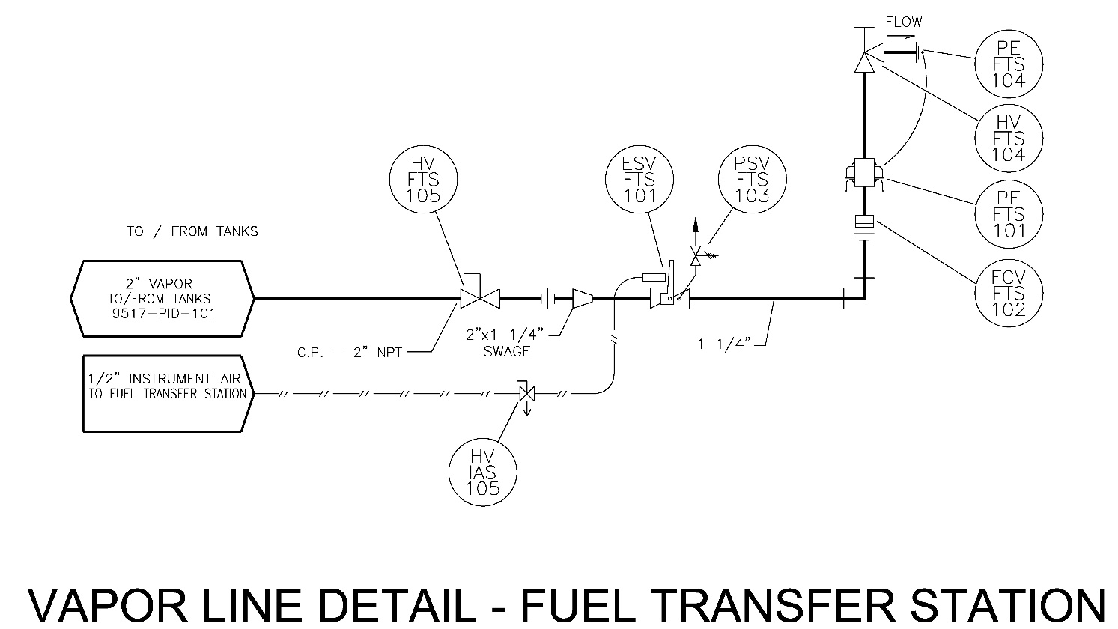

Figure - Vapor Line Detail Greenfield LP Plant Fuel Transfer Station

| Instrument TAG | Description |
| --- | --- |
| PE-FTS-101 | FTS Bulkhead |
| HV-FTS-104 | Angle Valve (FTS Vapor Line) |
| PE-FTS-101 | FTS Bulkhead |
| FCV-FTS-101 | Flow Control Valve (FTS Liquid Line) |
| PSV-FTS-103 | Hydrostatic Relief Valve (FTS Vapor Line) |
| ESV-FTS-101 | Emergency Shutoff Valve |
| HV-IAS-105 | Pneumatic Isolation for ESV Valve |
| HV-FTS-105 | Isolation Ball Valve (FTS Vapor Line) |

Table - Vapor TAG Detail Greenfield LP Plant Fuel Transfer Station

### North Adams LP Transfer Station

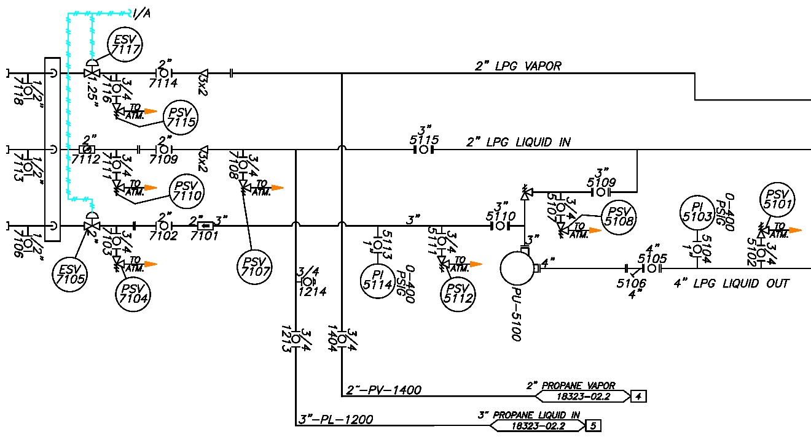

Figure - Line Detail North Adams LP Plant Fuel Transfer Station

| Instrument TAG | Description |
| --- | --- |
| ESV-7105 | Control Valve, Combination Bulkhead 7100, 2" |
| ESV-7117 | Control Valve, Combination Bulkhead 7100, 1.25" |
| PI-5103 | PU-5100 Outlet |
| PI-5114 | PU-5100 Outlet |
| PSV-5101 | 5102 Ball Valve Open 3/4, 4" LPG Liquid Out |
| PSV-5108 | 5107 Ball Valve Open 3/4, 4" LPG Liquid Out |
| PSV-5112 | 5111 Ball Valve Open 3/4, 3" LPG Liquid Out |
| PSV-7104 | 7103 Ball Valve Open 3/4, 3" LPG Liquid Out |
| PSV-7107 | 7108 Ball Valve Open 3/4, 2" LPG Liquid In |
| PSV-7110 | 7111 Ball Valve Open 3/4, 2" LPG Liquid In |
| PSV-7115 | 7116 Ball Valve Open 3/4, 2" LPG Vapor |

Table - TAG Detail North Adams LP Plant Fuel Transfer Station

### Pittsfield LP Transfer Station

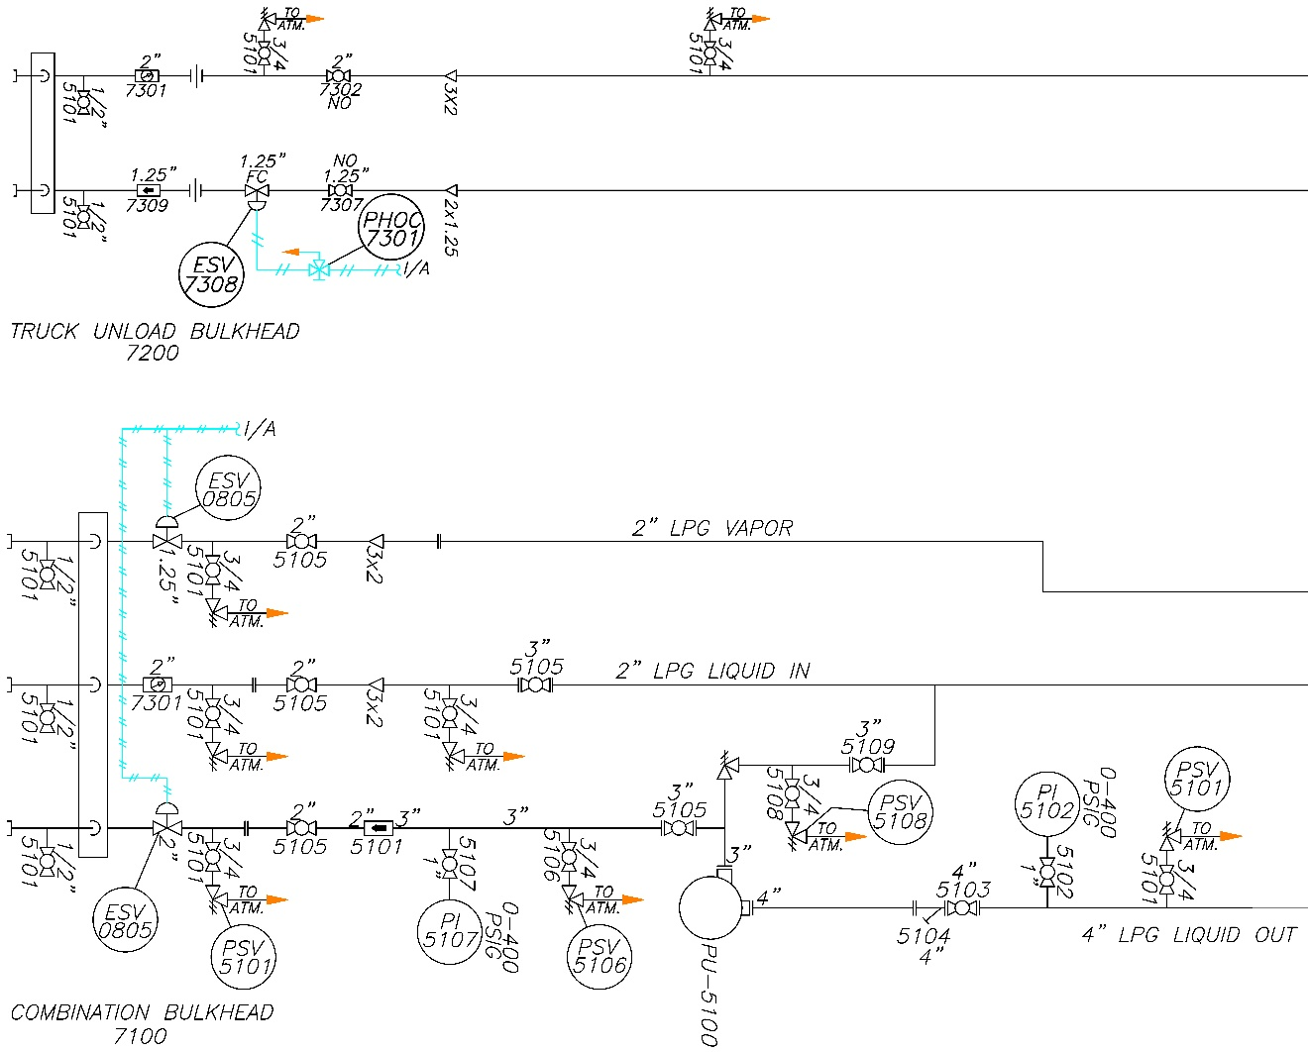

Figure - Line Detail Pittsfield LP Plant Fuel Transfer Station

| Instrument TAG | Description |
| --- | --- |
| ESV-0805 | Control Valve, Combination Bulkhead 7100 |
| ESV-7308 | Propane Vapor Control Valve Truck Unload Bulkhead 7200 |
| PHOC-7301 | Instrument Air |
| PI-5102 | Propane Liquid Out Globe Valve Open 0-400 PSIG |
| PI-5107 | Globe Valve Open 0-400 PSIG |
| PSV-5101 | Relief Valve to ATM. |
| PSV-5106 | To ATM. |
| PSV-5108 | Relief Valve to ATM. |

Table - TAG Detail Pittsfield LP Plant Fuel Transfer Station

### Fuel Transfer Pump Data

| Specification | Greenfield | N. Adams | Pittsfield |
| --- | --- | --- | --- |
| Manufacturer |  | Corken | |
| Model |  | Z4500 | |
| Pump Type |  | Sliding Vane | |
| Case, head, rotor, relief-valve cap, bearing cap |  | Ductile iron ASTM A536 | |
| Cam |  | Gray iron ASTM A48, Class 50 | |
| Sideplate |  | Gray iron ASTM A48, Class 30 | |
| Vanes and Vane Drivers |  | Advanced Polymers | |
| RPM Range |  | 420–800 RPM | |
| Max. Differential Pressure: |  | 150 PSID (10.3 bar d) | |
| Max. Working Pressure |  | 400 PSIG (28.6 bar) | |
| Temperature Range |  | -25°F–225°F | |
| Flow Range |  | 41–400 GPM | |
| Internal Relief Valve |  | Yes | |

Table - Fuel Transfer Pump Data

# Vaporization

## Overview

An LPG Vaporizer must be used when large quantities of LPG vapor are required for a process. Without supplying heat to the liquid LPG, the expansion of large amounts of liquid into vapor will cause storage tanks, piping, and attached equipment to freeze; as well as resulting in a loss of pressure in the storage tanks due to cooling (auto-refrigeration).

The purpose of the Vaporizer is to add heat to the liquid LPG to negate the cooling effect that occurs due to the natural vaporization of LPG by expansion.

The process starts when liquid LPG enters the unit at the rear of the Vaporizer via a 2-inch liquid inlet piping train. From there, the LPG makes passes through a series of finned tubes (also called “vapor tubes”) immersed in a hot water/glycol bath. The direction of flow through the finned tubes is such that all LPG must pass through all tubes, thus lengthening dwell time to ensure complete vaporization and appropriate superheating. Super-heated LPG vapor exits the Vaporizer at the vapor outlet, also located at the rear of the Vaporizer.

The Vaporizer is fitted with a gas-fired power burner that provides the heat required for vaporization. The burner raises the water/glycol bath temperature to at least 180°F (82°C) by firing directly into a set of steel burner tubes. These burner tubes are immersed in the water/glycol bath below the vapor tubes. A temperature transmitter serves as the bath thermostat and controls burner operation to maintain the desired bath temperature.

Before the burner can begin providing heat energy, certain safety conditions, unique to a given vaporizer, must be met. Once these safety functions are satisfied, the burner can start, and the Vaporizer can begin generating hot propane vapor.

The Vaporizer utilizes a mix of water/propylene glycol solution as the heat transfer medium.

A PeakShaving system is used to cover the “peaks” when energy demand exceeds energy availability. In the case of natural gas distribution grids, this is achieved by injecting a mixture of LPG and air into the existing natural gas pipeline. The LPG and air are blended together at an exact ratio so that the two gases have the same Wobbe Index as natural gas. The Wobbe Index relates the specific gravity and calorific valve of gas into a unitless number and serves as a measure of the interchangeability of gases; meaning that two gases with the same Wobbe Index are completely interchangeable.

“Ideal” natural gas is generally taken to have a calorific value of 1,000 BTU/ft³ and a specific gravity of 0.6 (lighter than air). This results in a Wobbe Index of 1291. In order to match this Wobbe Index, Propane (HD-5) and air are generally blended at a ratio of approximately 58.5% Propane and 41.5% air. The resulting Synthetic Natural Gas (SNG; also called Propane/Air) has a calorific value of 1475 BTU/ft³ and a specific gravity of 1.31. The quality of the SNG is often evaluated by measuring the specific gravity of the mixture. While 1.31 is often taken as “ideal” when an HD-5 Propane feedstock is used, values from 1.27 to 1.33 are often acceptable.

There are several components required to construct a complete PeakShaving System. The main system components are listed below and additional details for each are:

LPG Bulk Storage (Tanks)

LPG Liquid Pressurization

LPG Liquid Vaporization

LPG/Air Mixer

Gas Properties Analyzer

Gas Properties Controller

PeakShaving SNG Flow Control System

Main Control System

### Greenfield LP Plant Vaporization

The Greenfield LP Plant incorporates an Algas SDI Aquavaire Vertical Waterbath Vaporizer, Model Q1650V.

The Algas-SDI QV models are indirect fired waterbath LPG vaporizers. The units vaporize liquid LPG from a storage source by passing it through a heat exchanger immersed in a heated water/glycol mixture. A fixed air forced draft burner keeps the waterbath at the required temperature. The QV is designed for outdoor installation as a baseload or standby system, and is offered in sizes ranging from 320 to 1650 gallons of propane per hour.

The standard unit is Factory Mutual (FM) approved. Options include Industrial Risk Insurers (IRI), or Canadian Gas Association (CGA) burner controls, and a standby electric bath heater.

The Q1650V System basic features:

* An indirect fired LPG VAPORIZER composed of two heat exchangers, burner, and a waterbath heat transfer medium. FUSES in the control box prevent overloads.
* A cabinet houses the ANNUNCIATOR ALARM DISPLAY to aid troubleshooting. Should a safety circuit fail, the annunciator displays an alarm code.
* The SAFETY CIRCUIT will shut down on high waterbath temperature, LP level carryover, high and/or low burner gas supply pressure, low waterbath level, or burner failure. It includes an electronic flame safeguard to ensure safe burner operation via constant flame monitoring.
* A time delay relay will prevent the vaporizer from shutting down if there is a momentary loss of power or a momentary opening of one of the safety switches.
* An Auto Restart time delay relay restarts the vaporizer if power is lost for 3 seconds or more.

### N. Adams and Pittsfield LP Plant Vaporization

The N. Adams and Pittsfield LP Plants both incorporate an AES WB-3505/POM-40-8HV Water Bath Vaporizer/Piston Operated Mixer.

The Vaporizer and Mixer are manufactured to meet or exceed industry specifications in Section VIII of the American Society of Mechanical Engineers (ASME) Boiler & Pressure Vessel Code and the latest editions of NFPA #58, #59, and #70. The Vaporizer and Mixer units are approved by Factory Mutual (FM) and the Canadian Standards Association (CSA).

General specifications of the Vaporizer and Mixer units are listed in Table 10 below.

| WB-3505 | | POM-40 | |
| --- | --- | --- | --- |
| Vaporization Capacity (HD-5) | 3505 GPH (14,860 LB/H) | Mixer Maximum Capacity 75 PSIG Sendout and Above | 323 MMBTU/HR 323 MSCFH NatGas |
| Energy Equivalent | 323 MMBTU/HR  323 MSCFH NatGas | Mixer Minimum Capacity 75 PSIG Sendout and Above | 25 MMBTU/HR 25 MSCFH NatGas |
| Bath Capacity | 2,035 GAL | Mixer Design Temp. | 180°F (82°C) |
| Vaporizer Design Temp. | 650°F (343°C) | Mixer Maximum Inlet Pressure | 250 PSIG |
| Vaporizer Design Pressure | 250 PSIG (17.2 BARG) | LPG Vapor Inlet Connection | 4-inch 300# RF ANSI Flange |
| LPG Liquid Inlet Connection | 2-inch 300# RF ANSI Flange | Compressed Air Inlet Connection | 4-inch 150# RF ANSI Flange |
| Vapor Outlet Connection | 4-inch 300# RF ANSI Flange | Mixed Gas Outlet Connection | 6-inch 150# RF ANSI Flange |
| Burner Fuel (Natural Gas) Connection | 1-inch FNPT | Process Air Requirement @ 300 MMBTU/HR | 1,400 SCFM |
| Vaporizer Firing Rate (High Fire) | 5.3 MMBTU/hr 5.3 MSCFH NatGas | Minimum LPG & Process Air Inlet Pressure (for 100 PSIG discharge) | 125 PSIG |
| Vaporizer Dry Weight | 18,000 LBS | Required Control Air Pressure | 80-120 PSIG |
| Operating Weight | 34,250 LBS | POM Enclosure Dry Weight | 10,000 lbs |
| Footprint (L x W) | 278.0” x 80.5” | POM Enclosure | Modified 20-ft ISO Shipping Container |
| Electrical Requirement | 480/3/60 @30 Amps, 120/1/60 @10 Amps | 240” x 96” | 240” x 96” |
|  | | Electrical Requirements | 480/3/60 @30 Amps, 120/1/60 @5 Amps |

Table - Vaporizer and Mixer General Specifications

## Plant Emergency Shutdowns

### ESD Emergency Shutdown Activation

There is an automatic emergency shutdown (ESD) for certain facility equipment. If an operator observes an event requiring a manual ESD, the ESD stations are located at each exit from the facility and at the exit of each room of the control building. A manual ESD can also be initiated from the HMI either locally or remotely.

Pneumatically actuated emergency safety valves (ESV) are also installed on all major liquid and vapor lines. These valves are connected to the facility ESD system by stainless steel tubing and reinforced rubber hose. Instrument air compression and air-drying is used to pressurize and energize the ESV pneumatic actuators, thus holding the ESV valves open during normal operations. ESV valves located throughout the facility, as identified on the P&ID, will close upon activation of the ESD system. A fire in the facility will be sensed by the flame, heat or smoke detectors, which will cause an automatic ESD to be initiated.

Manual operation of the ESD system will isolate the vapor and liquid lines leaving the tanks, close the LP flow control valve to the inlet of the vaporizer, and the boiloff and vaporizer discharge temperature shutdown valves.

The objective of the ESD system is to quickly isolate the tanks from the rest of the facility in the event of an abnormal incident such as a component malfunction, leak, spill, or fire.

### Relief Valves

Thermal relief valves are installed on the LP piping between all sets of block valves or other areas where LP can become trapped and expand following ambient heat transfer. These valves are designed to relieve the vapor pressure buildup due to the thermal expansion of the LP and its vapor once the pressure has exceeded the setting of the relief valve. They are also provided on the glycol system, plant air system and odorization system to prevent over pressurization of these respective systems.

### Gas Detection

Infrared gas detectors, located at several locations throughout the facility, provide a first line of detection in the mitigation of a potential accident due to leaking LP or other combustible gases.

In response to an infrared gas sensor alarm, visual verification of the source should be attempted by on site personal or the Closed-Circuit Television (CCTV) system before any emergency procedures are initiated. If any doubt exists; however, begin emergency procedures.

### Fire Detection

Ultraviolet/infrared flame sensors are located at various facility locations to provide an indication of a localized fire situation. If only one sensor is on alarm mode and other facility condition indicators (e.g. gas detectors, auto fire panel alarms, pressure, flow, and temperature indicators/alarms) do not indicate the presence of an actual fire visually verify by on site personal or the CCTV system the existence of fire.

During the investigation, limit the personnel exposure to potentially hazardous situations by assuming the indicated condition is correct.

### Alarm Annunciators

To alert facility personnel of potential hazards, buildings and facility areas are provided with audible alarm devices. The operating personnel shall be familiar with the various alarm sounds and planned response for each sound.

Contractor personnel and visitors should be instructed to leave any building in which an alarm sounds and proceed immediately to the control room.

### Fire Protection

Three types of fire protection are present at the LP facility. The first are the wheeled dry chemical units located in the yard. Second is the availability of several hand-held dry chemical fire extinguishers located in each room of the control building and throughout the process area. Third is the fire water system with hydrants accessible from the facility (Greenfield and Pittsfield).

## HMI Screens

### Greenfield description and/or technical specifications/Plant Flow Diagrams

### N. Adams and Pittsfield Manual PLC Controls with Local Color Touch Screen

The vaporizer in this system utilizes a high efficiency burner to achieve maximum vaporization capacity. All Burner Safety Functions are controlled by a Honeywell Flame Safeguard system.

All other system operating parameters, including vaporizer, blender, etc., are controlled by a Programmable Logic Controller (PLC; GE Rx-3i) with Remote I/O. The CPU scans its local I/O and the remote I/O and communicates with two Electronic Operator Interfaces (EOI; GE

QuickPanel+; one in vaporizer control room; an identical panel in the main control room) via a standard Profinet connection. The EOIs have high-resolution (1024x768) color LCD displays with Touch Screen operator interface, offering expanded system control capabilities through menu-driven operator guidance.

The EOIs have several screens with soft keys and status indicator lamps. The layout of each screen changes in response to the requirements of the task at hand.

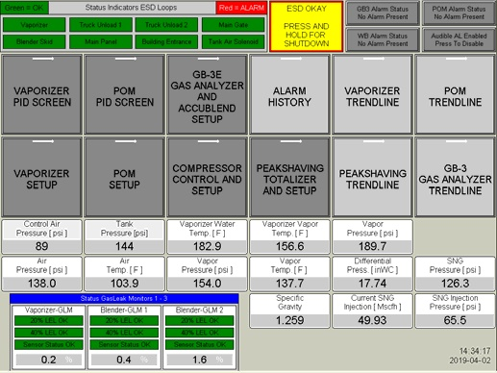

Figure 5 - Main Electronic Operator Interface (EOI)

All Vaporizer setup parameters can be found on the “Vaporizer Setup” screen. This screen gives access to transmitter range settings, Smart Liquid Carryover setup, Alarm setpoints, burner thermostat, timer settings, and burner usage statistics. general, dark gray buttons can be manipulated by the user and light gray areas are for display only and cannot be changed.

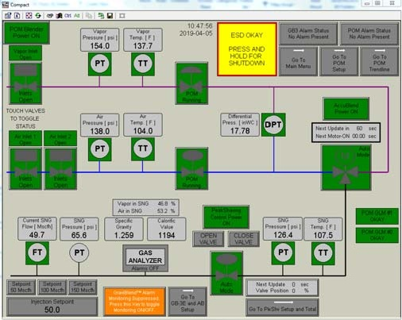

Figure 6 - Vaporizer EOI Flow Screen

All Vaporizer setup parameters can be found on the “Vaporizer Setup” screen. This screen gives access to transmitter range settings, Smart Liquid Carryover setup, Alarm setpoints, burner thermostat, timer settings, and burner usage statistics. In general, dark gray buttons can be manipulated by the user and light gray areas are for display only and cannot be changed.

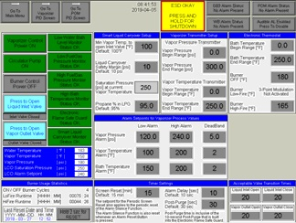

Figure - Vaporizer Setup EOI Screen

All POM setup parameters can be found on the “POM Setup” screen. This screen gives access to transmitter range settings, Alarm setpoints, timer settings, and air pressure control valve settings. In general, dark gray buttons can be manipulated by the user and light gray areas are for display only and cannot be changed.

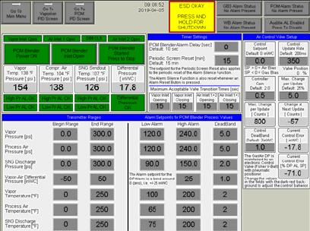

Figure - POM Setup EOI Screen

The POM is controlled from the “POM PID” screen. This screen shows a graphic representation of the POM Blender, its valves, and process values. Operation is controlled by pressing the associated element. For example, to open the POM Inlet valves, simply press any of the inlet valves on the HMI. Valve position feedback is shown above the valve.

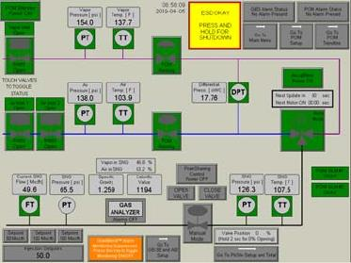

Figure - POM Blender Controls EOI Screen

# Gas Control Communications

## System Pressure Flow

(description and/or technical specifications)

# Job Classifications

## Overview

The following classifications of personnel are required to have the necessary training required as it relates to their job descriptions. The scope of the training will adhere to 49 CFR Part 193.

## Relevant sections of job descriptions related to LPG operations

### Director, LNG/LPG Plants

Oversees the operation and maintenance of facilities - LNG/Propane Air Plants.

### Manager, LPG Plants

Provides for the safe and efficient operation of the LPG Plants. Ensures monthly operations and maintenance schedules are completed. Performs security duties associated with position. Assures conformance with established safety and security methods by all personnel within LPG Plant.

### Supervisor, LPG Plant

Train and assign duties and work schedules to all personnel related to above responsibilities. Respond to all emergency situations deemed necessary. Performs security duties associated with position (see Section 15 of LPG Operations Manual).

Direct shift liquefaction and vaporization operations of the LPG Plant facilities; assists Manager and Director of Production and Gas Control by recommending improved operating techniques, efficiency, and safety.

Supervises LPG operators; instructs, trains, and assures compliance with established safety and job procedure standards.

Supervises maintenance and repair procedures during operation of LPG plant facilities; evaluates all operating problems and responds with appropriate corrective action; coordinates with Manager on problems that arise.

Performs security duties associated with position (see Section 15 of LPG Operations Manual). Assures conformance with established safety and security methods by all personnel within LPG Plant.

### Senior or Technical Support Specialist

Assigned administrative functions for the LPG Policies and Procedures, create and maintain the LPG and Procedure Index, create and maintain the LPG Management of Change Index, post new and revised Policies and Procedures, remove canceled Policies and Procedures, assign new Policies and Procedures numbers and maintain all plant files.

### LPG Technician

Under general supervision starts, stops and adjusts all equipment required for the storage, vaporization and transportation of liquefied natural gas. Maintains records of equipment performance as required.

Performs repair and maintenance work on all LPG Plant facilities. Performs scheduled lubrication, parts replacement, re-pairs, instrument calibration or equipment overhauls in accord with established schedules or as required by break-down. Prepares and maintains such records and reports as may be necessary to administer and control plant operation.

Makes scheduled inspection tours of plant facilities to check condition of equipment for operational, safety, and security purposes. Maintains building and property as required. Performs other related duties as assigned. Performs security duties associated with this position. (description and/or technical specifications).

# Training Components/Checklist

## Overview

The training of all LPG Plant personnel in Operations, Maintenance, Security, Safety, Fire Protection should be completed within the first 6 months of joining the LPG Plant.

## Duties

LPG technician training will continue regardless of the mode of operation. Subparts of training schedule, review of LPG Plant procedures and assignments of reading equipment manuals will be assigned to the LPG technician trainee on under the direction of LPG Plant supervision. An oral question and answer period with supervision, as required.

The LPG technician trainee may not be assigned shifts before he is accepted as an LPG Technician. The trainee can work shifts only under the supervision of qualified LPG Plant personnel.

Depending on LPG Plant operation, duties may change.

* If the LPG Plant is in vaporization mode, the LPG technician trainee will be involved with operating the plant with qualified technicians and the taking of readings.
* If the LPG Plant is in stand-by maintenance mode, the LPG technician trainee will be involved, under a qualified technician’s supervision, with some equipment maintenance.

Use the checklist provided at the end of this Manual in Section 8. New LP Plant Personnel Checklist to guide LPG Plant personnel in Operations, Maintenance, Security, Safety, Fire Protection training procedures.

# Re-evaluation

## Overview

Should an LPG Technician have a prolonged absence or have demonstrable indications that the Operators ability to perform the Operators’ Minimum Duties then management may require partial or full retraining.

## Review of Contractor Training Requirements

The Company will review applicable contractor capabilities and training requirements associated with the scope of the work that is being performed for the particular job.

The following training components are to be completed on a reoccurring basis as defined in this manual. Review these requirements as follows:

| Schedule | Component |
| --- | --- |
| Every Year | LPG Security Manual |
| First Responders attend the NGA “LPG Trucking Emergency Response Plan” |
| Respirator Fit Test (Not mandatory training) |
| Every Year (online) | Confined Space |
| Every 2 Years | Emergency Manual |
| LNG Operations Manual |
| Hazard Communication "RIGHT TO KNOW" |
| LNG Maintenance Manual |
| Valve Basics Actuator, Ball, Body, Bonnet, Butterfly, Check, Classification Of Valves, Controlling Valves, Cryogenic, Diaphragm, Flanged, Globe, Material Selection, Needle, P&ID Symbols, Packing, Safety/Relief, Threaded, Trim, Valve Basics, Valve Connections, Valve Parts, Valve Types, Welded |
| Calibration Process and Calibration Documentation Expectations |
| Abnormal Operating Conditions |
| Vaporization Training |
| Hot Work Permit |
| Fire Watch |
| MOC Training |
| Utility Safe Badging Program |
| First Aid Training (CPR/AED) |
| Every 3 Years | Massachusetts Fire Academy |
| Initial/Reevaluation (if necessary) | GTI LNG Operators Training |
| New Management Employees. | NGA Gas Operations School |

Table - Reoccurring Training Components

# New LP Plant Personnel Checklist

## Procedure

PRINT THIS SECTION AND USE THE CHECKLIST FOR NEW LP PLANT PERSONNEL

|  |  |
| --- | --- |
| ⬜ | 1. Qualification Cards - The cards are intended to provide a checklist of items that are reviewed with the employee and then either discussed, simulate or performed to ensure the trainee retained the information that has been reviewed with the trainee. |
| ⬜ | 1. HMI LOTO function on HMI System. |
| ⬜ | 1. LP Plant Tour/LP Hazards Training Power Point Presentation: |
|  | * 1. Complete a through tour of the LP Plant and a general explanation of the plant equipment |
|  | * 1. Training on the characteristics of LP. The training can include reading AGA “Introduction to LP for Personnel Safety” |
|  | * 1. Review other flammable fluids used and/or handled at the LP plant using the SDS sheets. Particular attention will be given to health, safety, and flammability |
|  | * 1. Explanations of the hazards involved in operation and maintenance activities: |
|  | * + 1. The LP Plant is broken down into two areas: |
|  | * + - 1. Class 1 Division 1, Group D |
|  | * + - 1. Class 1 Division 2, Group D These areas are defined on the “Electrical Area Classification” drawings are available Class 1 areas have the potential for having a combustible gas mixture Division 1 areas have the potential for a combustible mixture as a normal occurrence, such as near a natural gas vent or because of leakage or repair Division 2 areas contain hazardous materials, usually in a closed system Division 2 areas may contain combustible mixtures during maintenance or leakage Non-hazardous areas do not usually contain combustible mixtures. The only time that a non-hazardous area may contain a combustible mixture is after a major spill of LP. |
|  | * 1. An oral question and answer period with supervision, as required. |
| ⬜ | 1. Estimating LP truck deliveries to refill LP Tank methodology: |
|  | * 1. Use total days to fill tank by October 1st and multiply by 40 MCFD to account for boiloff and subtract from total volume of tank. Determine how many trucks (max 4 per day) the LP Plant can take Monday through Friday to arrive at a fill pattern that ensures the tank is as close to full as possible starting October 1st and subsequently throughout the heating season. |
| ⬜ | 1. Safety, Security, Plant Emergency, Monitoring and Communication Systems: Review corporate and plant safety procedures. Including but not limited to “Safety Talks”, confined space policies and procedures, hot work permits for welding and power tools, etc. Lock out Tag out procedures, etc. |
| ⬜ | 1. LP Plant ESD (Emergency Shutdown) system its function and operation. |
| ⬜ | 1. Gas Detection System and its function and operation. |
| ⬜ | 1. Fire Detection System and its function and operation. |
| ⬜ | 1. LP Plant Safety Alarms location and its function. |
| ⬜ | 1. Fire alarms to local fire and police departments. |
| ⬜ | 1. Types of firefighting equipment their locations, function, and operation. |
| ⬜ | 1. Main control room alarm panel, its function and operation. |
| ⬜ | 1. Complete BG-QC-007 Initial Security Training Qual Card. |
| ⬜ | 1. ZEIM’s System - This is where all this accounting for the P Card purchases get entered. |
| ⬜ | 1. E-GO (Supervision Only): |
|  | * 1. U # retrieval - Who’s Who’ - Avangrid - Click on the name and the U # is found next to Employee/EE. |
| ⬜ | 1. Shift selection: |
|  | * 1. Choice is determined by seniority of LP Plant personnel. |
| ⬜ | 1. Control room monitoring duties: |
|  | * 1. Access control |
|  | * 1. Visitors. |
| ⬜ | 1. Records Retention schedule - See LP-004 Records Retention procedure. |
| ⬜ | 1. SAP LP Procedure nomenclature: |
|  | * 1. Vaporization - BG-MP-XX |
|  | * 1. Other - BG-MP-XX. |
| ⬜ | 1. Trucking reconciliation - Training for Management only. |
| ⬜ | 1. LP Inventory Sheet - Training for Management only. |
| ⬜ | 1. SCADA Security Login levels: |
|  | * 1. Operator - Normal operating functions |
|  | * 1. Supervisor - Access to P&ID parameters |
|  | * 1. Administrator - Full access to coding and establishing passwords. |
| ⬜ | 1. ISNetworld - Training for Management only, and is a contractor safety program to: |
|  | * 1. Qualify contractors to work for Avangrid Networks |
|  | * 1. Gather and maintain contractor information |
|  | * 1. Communicate policies and change requirements with contractors |
|  | * 1. Gather contractor reporting. |
| ⬜ | 1. Contractors working within the LP Plant: |
|  | * 1. Orientation - Review “LP Facility Awareness and Hazards Training” |
|  | * 1. Security Guards - see Security Manual |
|  | * 1. Contractor Work Rules |
|  | * 1. Utilisafe Work badges |
|  | * 1. What to do in an emergency |
|  | * 1. General access & designated areas |
|  | * 1. Communications - Radio and use |
|  | * 1. Lockout Tagout |
|  | * 1. Control Room |
|  | * 1. LP Plant Buildings |
|  | * 1. Parking. |
| ⬜ | 1. Introduction to LP Plant Manuals, Electrical Systems and Test Equipment: |
|  | * 1. Manuals: |
|  | * + 1. Company Emergency Manual |
|  | * + 1. Plant Manuals |
|  | * + 1. LP Security Manual. |
|  | * 1. Other LP Training Components: |
|  | * + 1. Loading and Unloading LP Trailers: |
|  | * + - 1. Supervision is to determine specific gravity of LP being trucked vs. LP in tank to determine top or bottom fill |
|  | * + - 1. Explanation of loading and unloading LP Trailers. Function and operation |
|  | * + - 1. Safety protection to be worn while loading/unloading trailers |
|  | * + - 1. Associated valves, hoses, piping and ESD systems |
|  | * + - 1. Operating procedures for LP trucking |
|  | * + - 1. What does a “HOT” trailer mean? How to cool down hot trailers. Review operating procedure |
|  | * + - 1. Valve functions and their operations. Operating procedures for using loading/unloading trailers |
|  | * + - 1. Readings and forms to be made out for LP trucking. |
|  | * 1. Environmental: |
|  | * + 1. Asbestos Awareness Power Point File |
|  | * + 1. Waste Streams |
|  | * + 1. Waste Storage: |
|  | * + - 1. Satellite accumulation areas versus storage areas. |
|  | * + 1. Spill management. |
|  | * 1. Snow removal: |
|  | * + 1. Review plant snow removal responsibilities. |
|  | * 1. Will be taken as soon as possible and/or the next available training classes: |
|  | * + 1. Electrical Safety - Applies to Electrician & Instrumentation level |
|  | * + 1. Calibration & Instrumentation - Applies to Electrician & Instrumentation level |
|  | * + 1. Personnel Protective Equipment |
|  | * + 1. Training for Fire Fighting |
|  | * + 1. First Aid |
|  | * + 1. Hazmat, and Safety |
|  | * + 1. GTI Operator Training course once accepted. The LP technician trainee will continue with a combination of “On the Job” and formal training |
|  | * + 1. Lockout Tagout |
|  | * + 1. Backhoe |
|  | * + 1. Safety Harness inspection and use |
|  | * + 1. Arc Flash awareness |
|  | * + 1. Management ONLY - Dig Safe, Blasting Tickets |
|  | * + 1. File storage structure - Show new employees where files are located. |
| ⬜ | 1. Car Seal Program: |
|  | * 1. The term “car seal” originated from the railroad industry. After box cars were loaded and the doors closed, a wire was placed through the handles and the ends connected with a seal mechanism. The rail car contents were considered intact as long as the seal remained unbroken: |
|  | * + 1. CNG purchases seals from Seals.com. |
|  | * 1. In the natural gas industry, car seals are a simple device used to lock or 'seal' a valve or vent in the open or closed position to prevent unauthorized operation |
|  | * 1. Valve or vent operation can only take place by cutting the seal, thereby giving evidence of either tampering, or activity by an authorized worker |
|  | * 1. The Car Seal Program is a similar concept to Lock-Out/Tag-Out. The primary difference being that Lock-Out/Tag-Out locks are installed to conduct maintenance activities safely, while Car Seals are removed to conduct maintenance activities safely |
|  | * 1. P&ID's shall mean the latest approved set of piping and instrument diagrams |
|  | * 1. Car Seal will mean a numbered securing device used to ensure proper valve position. These devices must be broken in order to operate the valves. A chain or band may be used to extend the length of the car seal on larger valves but the difficulty in removing the chain or band should be no less than the difficulty in removing the car seal device installed |
|  | * 1. Car Sealing shall mean the securing in either the open (CSO) or the closed (CSC) position as identified on the P&ID's, or by specific location for vents, and a car seal tag attached so that the valve, or vent, cannot be operated without removing the car seal |
|  | * 1. Severe Safety Incident shall mean any incident which could result in significant personal, equipment, and/or property damage |
|  | * 1. Responsibility: |
|  | * + 1. The LP Plant Manager/Supervisor will have the overall responsibility for assuring that the Car Seal Program is followed and enforced within their operation(s). An electronic copy will be maintained on the LP shared drive |
|  | * + 1. All plant employees and contractors are responsible for compliance with this Car Seal Program |
|  | * + 1. Personnel will maintain car seals intact and IMMEDIATELY turn in any Car Seal found out of place to the LP Plant Manager or LP Plant Supervisor. |
|  | * 1. Procedures |
|  | * 1. Manuals |
|  | * 1. Drawings & P&ID’s |
|  | * 1. OSHA Training - Hazard Detection to “protect the health and safety of any of our employees”: |
|  | * + 1. OSHA Hazard Communication Standard |
|  | * + 1. Methods and Observations used to detect presence and release. |
|  | * 1. Vacation & Fire Fighting Training Calendars |
|  | * 1. Hands on Fire Drill with local fire department |
|  | * 1. Job Briefing. |

END OF PRINT SECTION TO BE USED AS THE CHECKLIST FOR NEW LP PLANT PERSONNEL

# Appendix

## List of Tables

Table 1 - LP Plant Descriptions 2-1

Table 2 - LP Tank Liquid Levels 2-2

Table 3 - Piping External to the Tanks 2-4

Table 4 - Storage Tank Specifications 2-4

Table 5 - Liquid TAG Detail Greenfield LP Plant Fuel Transfer Station 2-6

Table 6 - Vapor TAG Detail Greenfield LP Plant Fuel Transfer Station 2-7

Table 7 - TAG Detail North Adams LP Plant Fuel Transfer Station 2-8

Table 8 - TAG Detail Pittsfield LP Plant Fuel Transfer Station 2-9

Table 9 - Fuel Transfer Pump Data 2-10

Table 10 - Vaporizer and Mixer General Specifications 3-3

Table 11 - Reoccurring Training Components 7-1

## List of Figures

Figure 1 - Liquid Line Detail Greenfield LP Plant Fuel Transfer Station 2-6

Figure 2 - Vapor Line Detail Greenfield LP Plant Fuel Transfer Station 2-7

Figure 3 - Line Detail North Adams LP Plant Fuel Transfer Station 2-8

Figure 4 - Line Detail Pittsfield LP Plant Fuel Transfer Station 2-9

Figure 5 - Main Electronic Operator Interface (EOI) 3-6

Figure 6 - Vaporizer EOI Flow Screen 3-7

Figure 7 - Vaporizer Setup EOI Screen 3-8

Figure 8 - POM Setup EOI Screen 3-9

Figure 9 - POM Blender Controls EOI Screen 3-10